Gameplay evaluation responses

**Race mode**

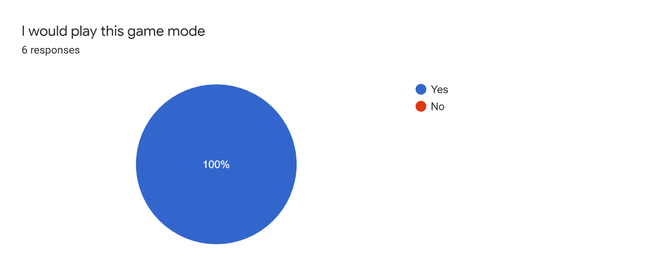

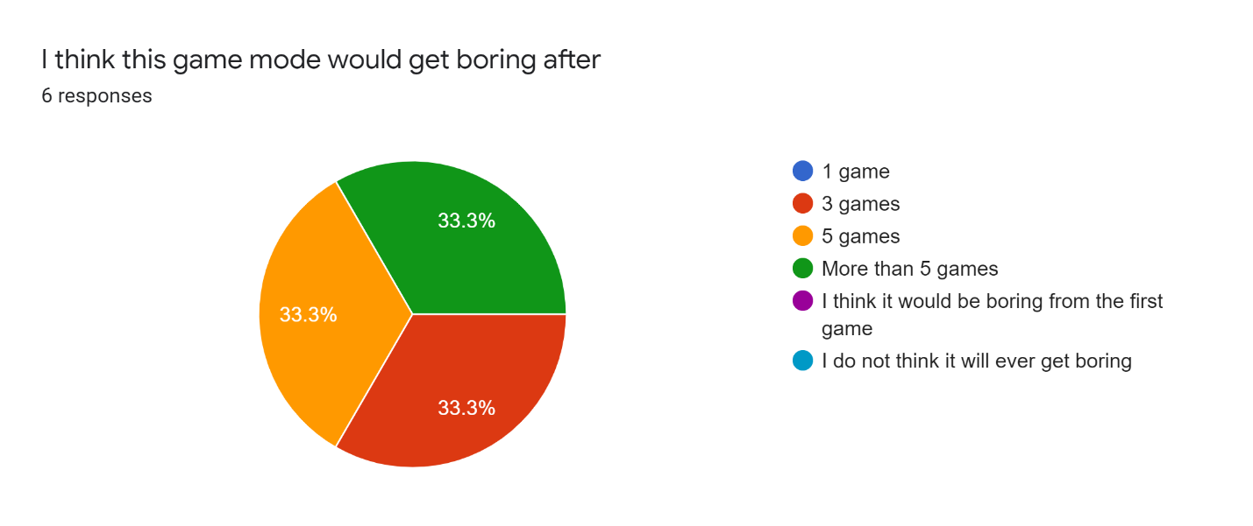

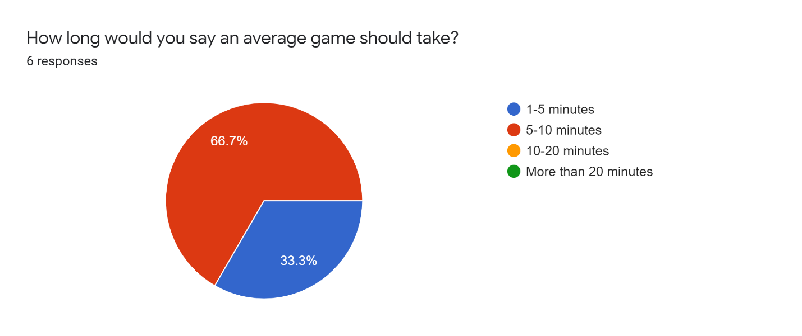

Anything else to add?

* Is it possible to provide more feedback to the players, so they can understand how to come up with strategies?

**Category mode**



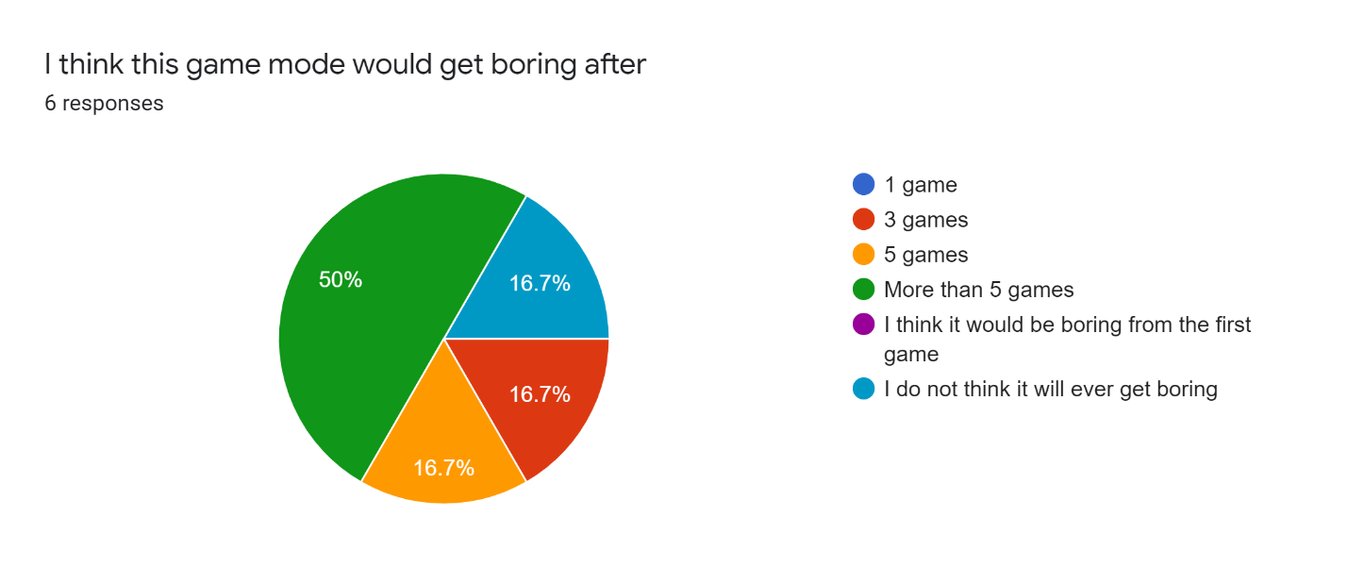

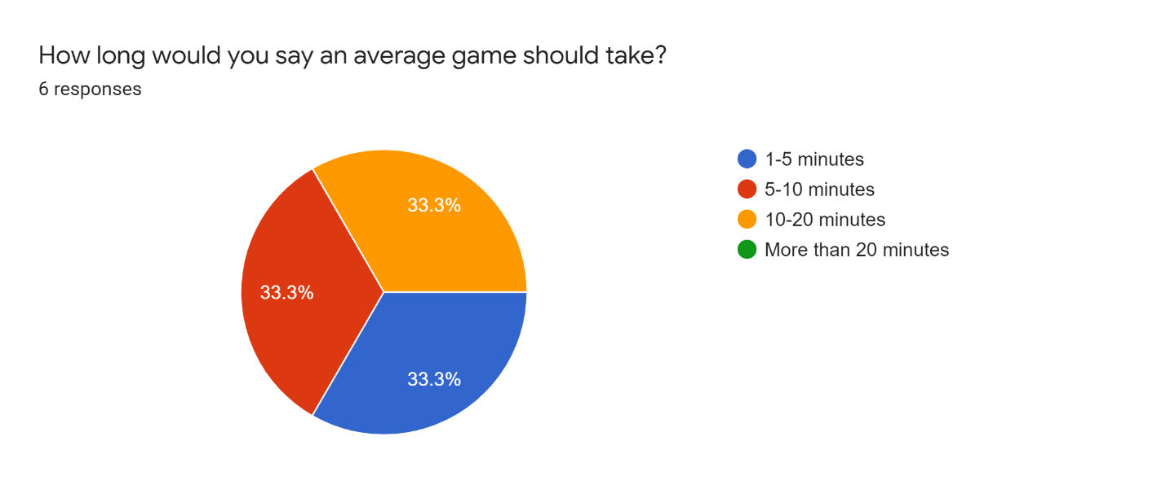

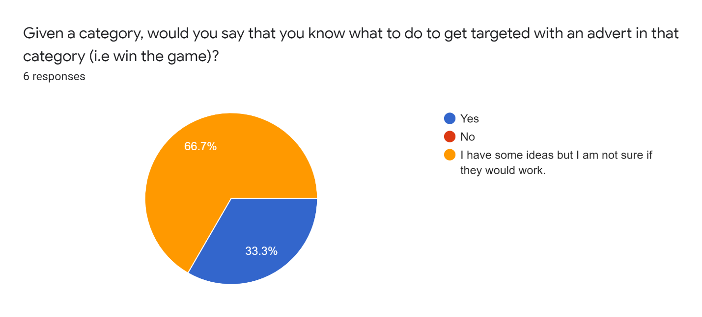

Anything else to add?

* Sometimes when you search on google for something, you get ads for that specific item. Maybe try to exclude some domains from the game in order to make it more interesting.
* The second game where the participants can vote for the advertismenet category, I believe will keep participants play more games than the previous game
* what happens if a player finds an advert instantly? Does the game end?

**Hunting mode**

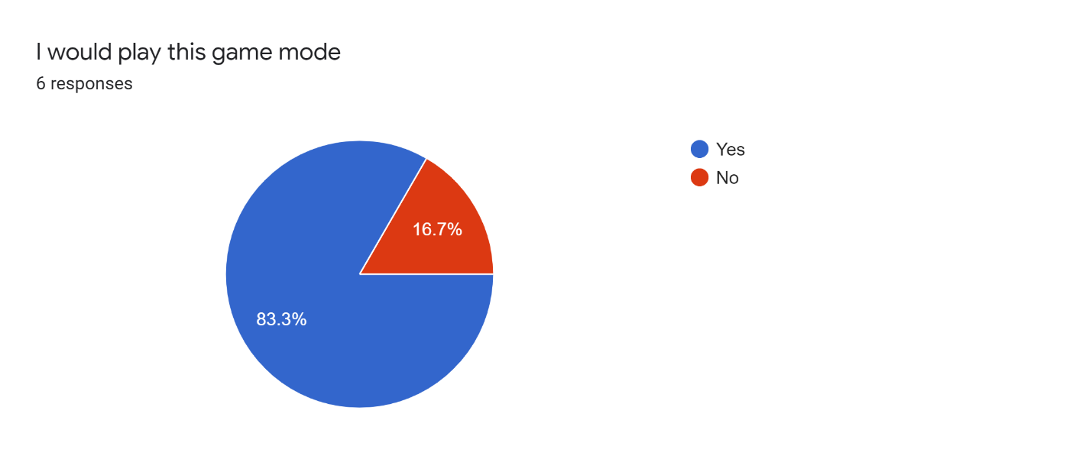

If you answered no to the question above, can you elaborate why?

* It does not seem that engaging, only the trading aspect

Is there anything that seems confusing about how to collect organisations?6 responses

* No
* no, but it seems impossible to know where to find a specific organization
* No. The explanation is intuitive
* How would a player know where to look for an organisation?

Is there anything that seems confusing about how to trade organisations?6 responses

* No
* No
* If player trades an organization, do they still keep it in their book? That could be explained a bit better.
* I don't see the purpose of trading if you cannot find a way to unlock the certain organization
* Maybe allow duplicate cards for trading purposes

Anything else to add?

* Maybe restrict the number of organisations to only those found in common websites (if that makes sense)
* What is the benefit of someone making a trade? Is it something like making a team trying to get all of the organisations provided?

**Additional questions**

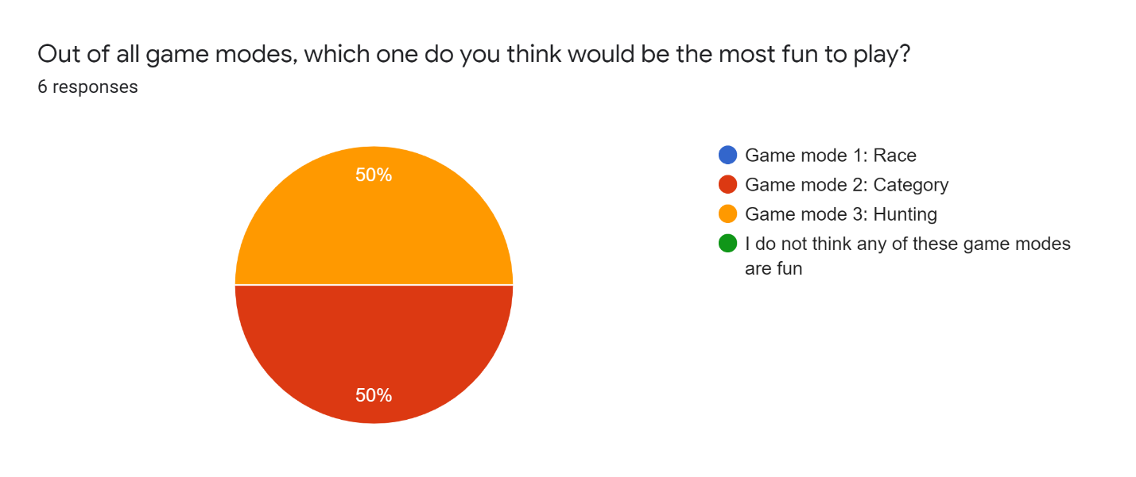

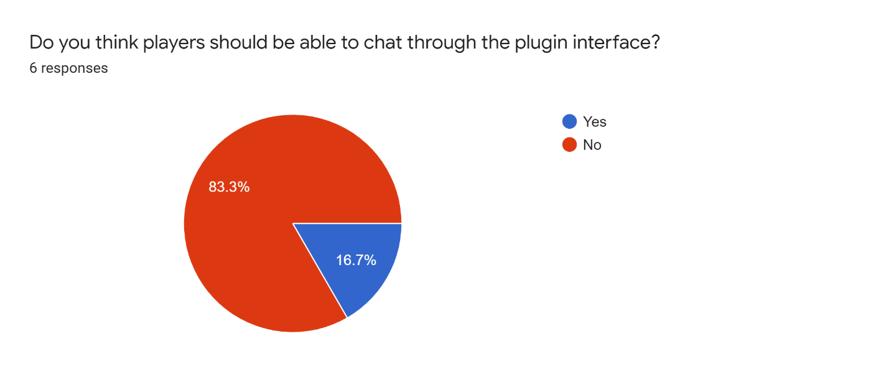

Do you have anything else to add about the game modes or the project in general?

* No
* Hunting is interesting but the final goal is not very clear for the players